**Backslash in string**

Backslash ‘\’ is a special character in JS used to make the next functions:

1. Cancel any special character locates after it.

We can say the next rule: {**any character was cancelled; it stops from doing its function (loses its function) and was printed as any other character**}

**To stop backslash from canceling next characters use another backslash:**



**1st backslash will stop the 2nd one from canceling 3rd one (because 2nd one has been cancelled it will printed as above rule). The 3rd one will cancel double quotes from making error (because double quotes has been cancelled it will printed as above rule).**

**Example: similar to the previous one**



1. **\n** is used to down in a new line.



1. **\xUTF-8 codes** are used to write characters by its [UTF-8](https://www.fileformat.info/info/charset/UTF-8/list.htm) code which starts with a number. (It’s useful with characters that weren’t existing in the keyboard)

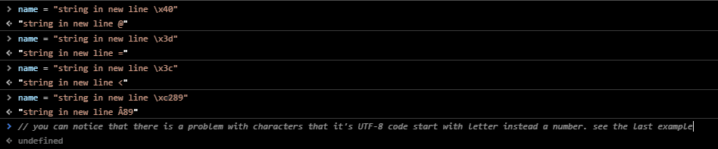

1. **\uUTF-8 codes** are used to write characters by its [Unicode](https://unicode-table.com/en/#03A9). (It’s useful with characters that weren’t existing in the keyboard)

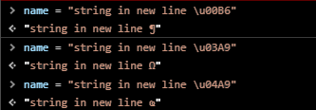

**Note:** if the printed symbol was Small Square (□) that means that your browser can’t print it.